East Knox 25/26 Second Grade Supply List
Backpack (No Wheels Please) | 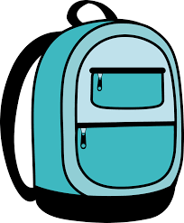 | 1 Pair of Blunt-Tip Scissors | 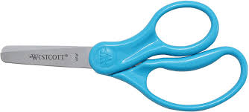
1 Pair of Headphones with microphone  (No Earbuds) | 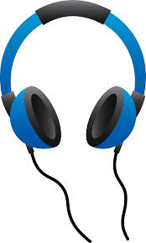 | 1 Plastic 3-Prong Folder | 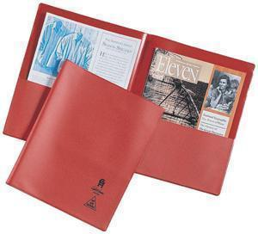
1 Box of Tissues | 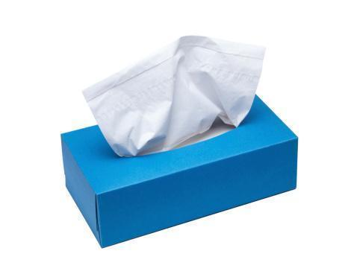 | 1 Pencil Pouch & Pencil Box | 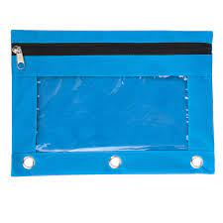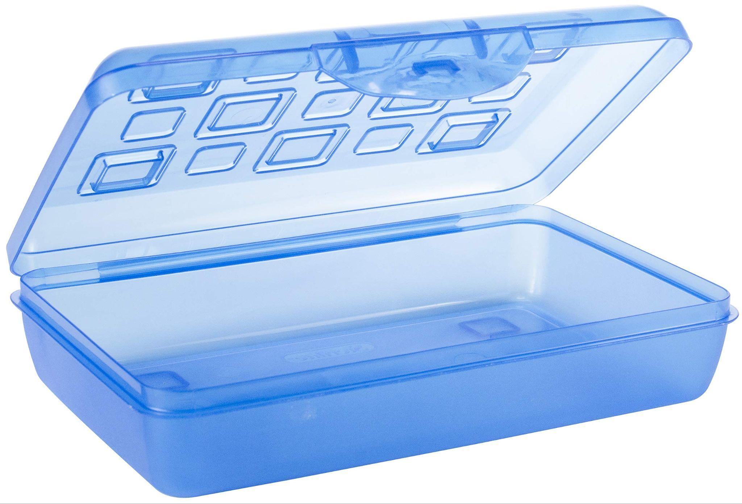
1 Pack of 4 Black Dry-Erase Markers | 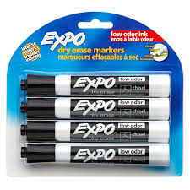 | 4 Glue Sticks | 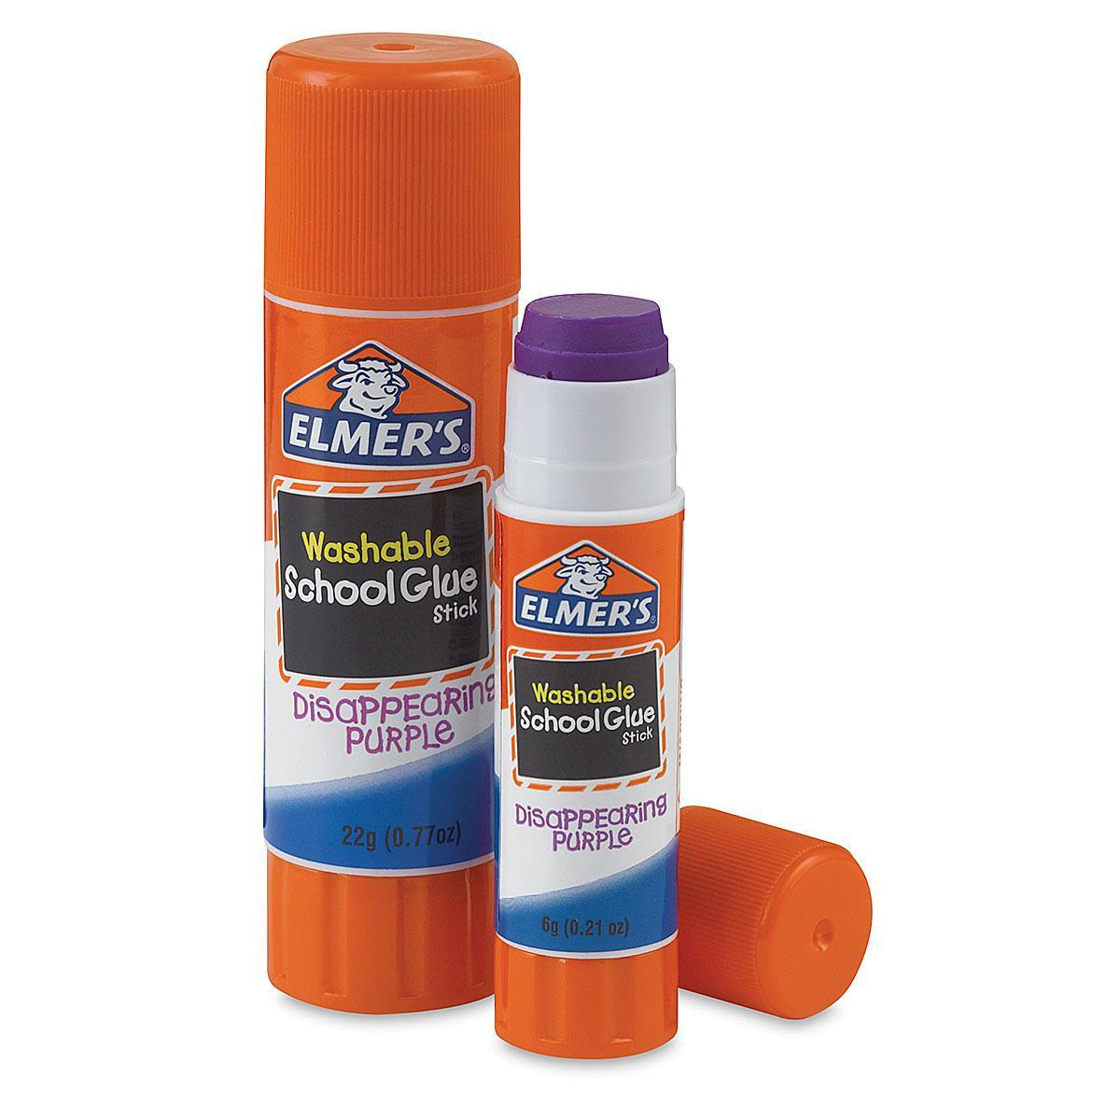
2 Boxes of 24-Count Crayons | 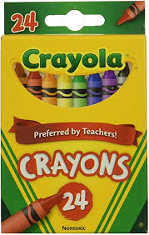 | 2 Packs of Plain No.2 Pencils | 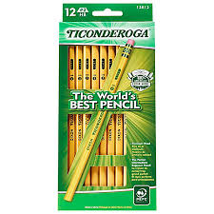
1-inch Binder | 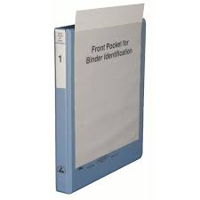 | Pencil Top Erasers | 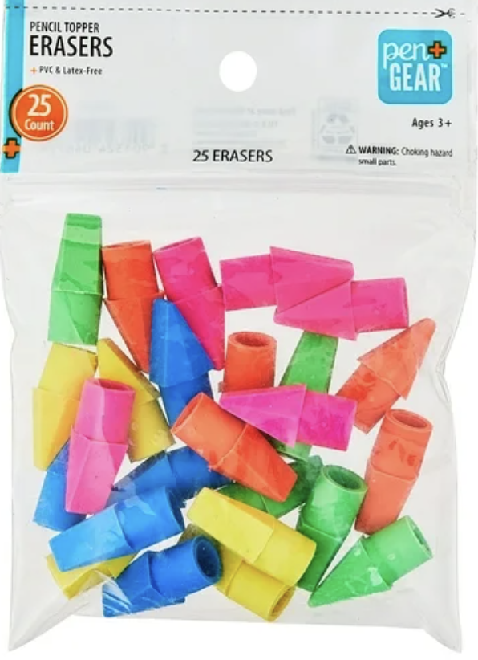
Spiral Notebook | 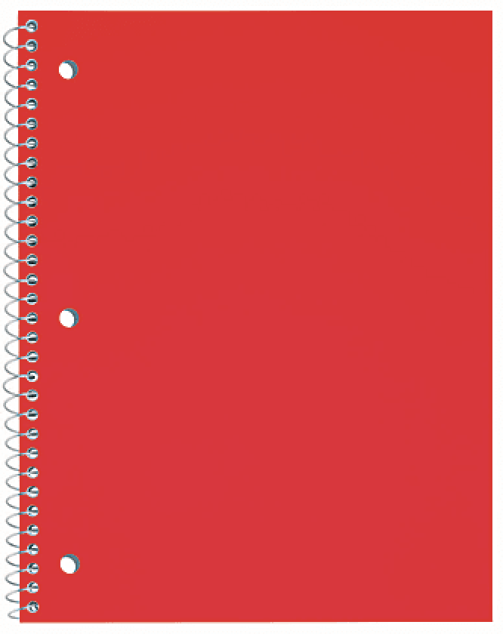
Wish List:  Extra Pair of Headphones  Bandaids | 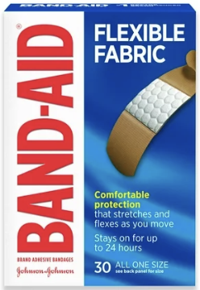 | Wish List:  Clorox Wipes  Extra Supplies above | 